

**Circles of Care**

**Health and Safety Plan**

**Circles of Care**

**Health and Safety Plan**

**Table of Contents**

1. Overview ………………………………………………………………………………….……………….. 3
2. Maintaining a Healthy and Safe Work Environment ……………………………….…….. 4
   1. Fire Safety ……………………………………………………………………………………….. 4
   2. Medical Emergencies ……………………………………………………………………..… 5
   3. Bomb Threats …………………………………………………………………………….….... 5
   4. Workplace Violence …………………………………………………….….………………... 6
   5. Natural Disasters/Severe Weather Events ………………………….….…………… 7
   6. Infection Prevention and Control ………………………………….…………………... 9

## Emergency Procedure Testing and Facility Inspections ……………………… 11

1. Maintaining Out-of-Office Health and Safety …………………………….……………….. 11
   1. Safe Driving Practices and Travel …..……………………………….………….…….. 11
   2. Transporting Clients …………………………………………………..…………….…….. 13
   3. Home-based Offices ………………………………………………………….……………. 13
2. Reporting and Documenting Serious Incidents …………………………………………... 14
3. Employee Training ……………………………………………………………………………………. 15
4. Appendices ………………………………………………………………………………………………. 16
   1. Office Evacuation Plans
   2. Emergency Phone Numbers & Emergency Codes
   3. Circles of Care Safety Check Form
   4. Responding to Bomb Threat Checklist
   5. Circles of Care Safety Drill Form
   6. Circles of Care Health and Safety Checklist
   7. Circles of Care Transportation Emergency Procedures
   8. Circles of Care Employee Incident Report

**Circles of Care**

**Health and Safety Plan**

# **Overview**

## Intent Statement

Circles of Care, as an agency, values all employees and is committed to maintaining the health and safety of all staff as a priority. This commitment to health and safety is fulfilled through the active participation of all staff, and is extended to all persons served, personnel, and other stake holders.

## Policy Statement

The Circles of Care Health and Safety Plan is designed to outline the protocols in place to maintain a safe and injury/illness free work environment for each program area. Accident prevention is a responsibility of and concern for all employees. This includes the safety and well being of employees, subcontractors, and persons served. Compliance with the Health and Safety Plan is mandatory for all employees of the company. It is the aim of Circles of Care to prevent accidents, injuries and illness resulting from all foreseeable workplace hazards and risks and to respond rapidly and appropriately when these occur.

## Applicability

The Circles of Care Health and Safety Plan applies to all employees of Circles of Care, regardless of position within the company. The health and safety protocols contained herein apply to all subcontractors, interns, and volunteers. Every employee is expected to comply with the Circles of Care Health and Safety Plan.

## Enforcement

The authorization and responsibility for enforcement of the Health and Safety Plan has been given primarily to the Safety Officer/Human Resources Director. The Program Director for each program area will share in this responsibility as well. The Safety Officer and Program Directors will meet at least annually to evaluate all areas of safety and make recommendations for changes as necessary to the State Administrator and Executive Director.

# **Maintaining a Healthy and Safe Work Environment**

## Fire Safety

Employees should be knowledgeable in fire prevention and emergency response in the work place. Major causes of fires in the work place include arson, smoking materials, wiring, and appliances. It is important to keep doors locked after business hours, keep areas near doorways and around building clear, and pay attention to housekeeping within the building. Smoking is not allowed in any Circles of Care offices/buildings. In designated smoking areas (located outside of the building, away from entrances), large, non-tip ashtrays should be used. Outlets should not be overloaded. Any broken or cracked electrical cords should be replaced immediately. Become familiar with the facility’s fire and life safety systems. Know what types of fire safety systems the building has, as well as their location –and how to use them (i.e., Fire extinguishers, Smoke detectors, Sprinklers, Alarms, Evacuation Plans).

## Fire Response Plan

If the fire/smoke alarm sounds, or a fire is suspected:

* Dial 911 immediately.
* Exit the building according to evacuation plan (close doors when exiting to help limit spread of smoke and fire). Never use elevators during a fire emergency. Proceed to the identified employee meeting place.

If an intercom system is available, Code Red should be announced; Skype or other instant messaging systems may also be utilized to announce the fire emergency.

*Fire Extinguisher:*In the event of a smaller, contained fire, call 911 and then utilize the fire extinguisher. If you are unable to extinguish the fire, leave and close the door behind you.

Evacuation Plans: Evacuation plans are kept on file and posted in each program office, in all common areas. Evacuation plans identify location of fire extinguishers and where everyone should meet so that each employee may be accounted for. The meeting location should be far enough from the building to provide safety for the evacuees, but also to allow for emergency responder access. See Appendix A for each office evacuation plan.

## Medical Emergencies

It is important to anticipate and plan for situations that may require on-site emergency medical care. Regardless of the type of emergency, medical procedures focus on three basic steps, which the American Red Cross identifies as Check-Call-Care.

* The first step is to secure the scene and check the injured person.
* If the situation is serious or life-threatening, the next step is to call emergency 911.
* Then, begin providing emergency life-support (CPR) and/or First-Aid services.

If an intercom system is available Code Blue should be announced; Skype or other instant messaging systems may also be utilized to announce the medical emergency.

All Circles of Care employees must be trained in First-Aid and CPR. All Circles of Care program offices are equipped with First-Aid kits. Circles of Care Evacuation plans all indicate where First-Aid kits are located within the office. Direct care employees also have First-Aid kits in their vehicles.

First-Aid kits must be inventoried on a quarterly basis, or after each medical emergency to ensure it is properly stocked. The inventory/stock will be documented on the Circles of Care Safety Check Form and submitted to the Safety Officer. If additional supplies are required, a purchase request will accompany the Safety Check Form.

## Bomb Threats

Bomb threats are made to warn people to leave a location where an explosive device may have been placed. Another reason for making a bomb threat is to cause alarm, panic, and get attention and response. Bomb threats are usually received by telephone. All personnel must be instructed in responding to bomb threats, especially those at the telephone switchboard.

It is always desirable that more than one person listen in on the call if possible. If possible, the person receiving the threat should notify other employees of the active threat. If an intercom system is available Code Yellow should be announced; Skype or other instant messaging systems may also be utilized to announce the bomb threat. The person receiving a bomb threat should remain calm and attempt to obtain as much information as possible from the caller (Appendix D Bomb Threat Call Checklist).

* Keep the caller on the line as long as possible
* Record/document every word spoken by the person if possible
* If the caller does not indicate the location of the bomb, ask for this information
* Pay particular attention to background noises which may give a clue as to the location of the caller
* Listen closely to the voice (male/female), accents, and speech impediments
* Immediately after the caller hangs up, call 911 and evacuate the building, according to identified evacuation plan
* Report the threat to immediate supervisor and Safety Officer

Each office should have a copy of the Bomb Threat Call Checklist accessible in any area where telephones are answered. The checklist should be used, if possible, to document the elements of the threat. A copy of the checklist should be provided to responding police officers, as well as to the Circles of Care Safety Officer.

## Work-place Violence

Work-place violence is any intentional act that inflicts, attempts to inflict, or threatens to inflict bodily hurt on another person or property, whether committed by a Circles of Care employee or by anyone else and which occurs in a Circles of Care program office or while an employee is engaged in Circles of Care business.

The following control measures are reliable and will provide protection for employees and assist in the prevention of work-related violence:

* The office building is secure and maintained
* Security measures are used (cameras) where available
* Internal and external lighting is installed to assist visibility
* Furniture and partitions are arranged to allow good visibility of service areas and avoid restrictive movement
* There is no public access to the premises when people work at night
* Supervisors are made aware of staff general whereabouts when making home visits or engaging in other work-related tasks within the community (transporting children to family visits, attending court hearings, etc.)
* The use or sale of alcohol, illegal, or non-prescribed drugs , or reporting for work under the influence of such substances is prohibited
* Displaying behavior that could endanger oneself or a fellow employee such as fighting, engaging in horseplay, and disorderly or disruptive behavior is prohibited
* All staff is trained in Emergency Behavior Intervention, which includes de-escalation techniques that may be used with any age group
* Supervisors should be watchful for problematic behaviors of employees (i.e., increasing belligerence, threats, apparent obsession with coworker, outbursts of anger, noticeable changes in behavior)

If violence occurs, employees should:

* Dial 911
* Evacuate the area immediately
* Help others evacuate/escape if possible
* Prevent others from entering the area
* If unable to evacuate, find a safe place out of the violent person’s view

Skype or other instant messaging systems may also be utilized to announce the threat and instruct employees to evacuate the building, Code Gray.

When interacting with the violent or threatening person:

* Use calm verbal and non-verbal communication
* Use verbal de-escalation and distraction techniques
* Ask the aggressor to leave the premises
* Retreat to a safe location if possible and call 911

## Natural Disasters/Severe Weather Events

A natural disaster is a major adverse event resulting from natural processes; examples include hurricanes, tornadoes, floods, severe thunderstorms, and winter storms. Being prepared and acting quickly is critical during the threat of severe weather.

Hurricanes are strong storms that can be life-threatening as well as cause serious threats such as flooding, storm surge, high winds and tornadoes.

* Listen to area radio and television stations for critical information from the National Weather Service
* Secure windows and doors; contact maintenance or landlords to assist
* Be prepared to evacuate
* Unplug, elevate, and secure all computers and other electrical devices
* Elevate all filing cabinets and/or move books, binders, paper items to higher areas of the offices

Severe thunderstorms may produce hail at least 1 inch in diameter and/or have wind gusts of at least 58 miles per hour. Every thunderstorm produces lighting and often has heavy rain that can cause flooding. High winds can cause structural damage, blow down trees and utility poles, and cause widespread power outages

* Listen to area radio and television stations for critical information from the National Weather Service
* Stay away from windows, skylights, and glass doors that could be broken by strong winds or hail

A tornado is a violently rotating column of air extending from the base of a thunderstorm down to the ground. Although severe tornadoes are more common in Plains States, tornadoes have been reported in every state.

* During any storm, listen to area radio and television stations for critical information from the National Weather Service
* If a tornado is approaching move to a small, interior room or hallway, on the lowest floor with no windows
* If an intercom system is available Code Orange should be announced; Skype or other instant messaging systems may also be utilized to announce the tornado warning/threat.

Floods are among the most frequent natural disasters. Conditions that cause floods include heavy or steady rain for several hours or days that saturate the ground.

* Listen to area radio and television stations for possible flood warnings and reports of flooding in progress or other critical information from the National Weather Service
* Be prepared to evacuate
* Unplug, elevate, and secure all computers and other electrical devices; cover in large trash bags
* Elevate all filing cabinets and/or move books, binders, paper items to higher areas of the offices
* Stay away from flood waters, walking or driving

The following steps will be taken to secure records during a natural disaster/severe weather event or in the event of other critical equipment failure:

* The Executive Director and IT Department will ensure that a back up is done of its centralized database program. Circles Backup Disaster Recovery Server (DHCP) is a Microsoft Windows 2008 R2 Standard, member server of the domain that asks a storage repository for all Shadow Protect backups of the other servers in the domain. It runs Image Manager for compression and management of the backup image files and RTS backup software for transfer of the files to our offsite backup data store. (Refer to COC Technology Plan for more information)
* Paper records will be secured and will be attempted to be protected as much as possible based on the type of disaster

## Infection Prevention and Control

Infectious Diseases (also called communicable diseases) kill more people worldwide than any other single cause. Infectious diseases are caused by germs. Germs are tiny living things that are found everywhere - in air, soil and water. You can get infected by touching, eating, drinking or breathing something that contains a germ. Germs can also spread through animal and insect bites, kissing and sexual contact. Vaccines, proper hand washing and medicines can help prevent infections.

Circles of Care recognizes the seriousness of infectious diseases and requires employees participate in training regarding the prevention of the spread of communicable diseases. All employees are also required to have a Tuberculosis (TB) screening when hired. The following general practices are encouraged to help stop the spread of germs in the work place:

When you cough or sneeze, you send tiny germ-filled droplets into the air. Colds and flu usually spread that way. You can help stop the spread of germs by:

* Covering your mouth and nose when you sneeze or cough. Sneeze or cough into your elbow, not your hands.
* Cleaning your hands often - always before you eat or prepare food, and after you use the bathroom or change a diaper
* Avoiding touching your eyes, nose or mouth

Hand washing is one of the most effective and most overlooked ways to stop disease. Soap and water work well to kill germs. Wash for at least 20 seconds and rub your hands briskly. Disposable hand wipes or gel sanitizers also work well.

The following are recommended hygienic practices for care providers and staff caring for people with infections disease.

* Spills of semen, blood, bloody saliva, urine, feces, or vomit on surfaces such as floors, bathtubs, etc. should be cleaned with a solution of ten (10) parts water to one (1) part bleach. The towel or cloth used for the cleanup shall be placed in a sealed plastic bag and put outside in a trash can. Disposable rubber gloves shall be used during the cleaning of any and all bodily fluid spills.
* Clothes that have been soiled with fluids shall be washed separately from other clothes with ten (10) part water to one (1) part bleach mixture.
* Bloody body fluids found in or on bottles, dishes, cups, or eating utensils shall be washed separately either by hand or in the dishwasher with hot soapy water.
* Disposable soiled diapers should be placed in a sealed plastic bag and placed in a trash can outside.
* If a child with an infectious disease bites someone and draws blood, the area should immediately be washed with hot water and soap and reported to a doctor.
* Care providers and staff are encouraged to assure that immunizations are up to date for childhood diseases such as mumps, Rubella, etc. as determined by their physician.

## Emergency Procedure Testing and Facility Inspections

Circles of Care employees are trained regarding the Health and Safety Plan during new employee orientation and annually thereafter. Emergency procedures must be reviewed with staff and practiced periodically to ensure comprehension and ability. Most office emergencies require evacuation as some part of the identified response.

## Evacuation Drills:Unannounced evacuation drills will be held in an effort to practice the evacuation plan. This is to occur on a biannual basis or as often as the Safety Officer deems appropriate. These drills will be monitored and used as a training tool. Any concerns noticed by the monitor or staff being evacuated will be discussed and addressed as necessary. Evacuation drills and subsequent observations/concerns will be documented by the Safety Officer on the Circles of Care Safety Drill form and submitted to the State Administrator and Executive Director for review. See Appendix E.

Other Safety Drills: The Safety Officer will instruct Program Directors in implementing additional unannounced drills, such as bomb threats, medical emergencies, and violence. The Program Director will announce the drill and explain the scenario to be simulated. Employees are to react as if it is an actual emergency and follow procedures. The Program Director will observe the response and document it accordingly. Documentation will be completed on the Circles of Care Safety Drill form and submitted and reviewed by the Safety Officer.

Facility Inspections: Annual facility inspections will be completed by a qualified external authority (fire/health inspector). Fire extinguishers will be inspected for required maintenance or service, annually by an approved external service provider. Annual inspections and any subsequent compliance inspections will be submitted to the Safety Officer. Biannual internal health and safety inspections will be completed by Program Directors. These inspections will be documented on the following forms: Circles of Care Safety Check Form and the Circles of Care Health and Safety Checklist. See Appendix C.

# **Maintaining Out-of-Office Health and Safety**

## Safe Driving and Travel Practices

Travel and field work is required and a core component of most employee roles within Circles of Care. Primarily, Case Managers and Foster Home Developers are required to travel (short distances and long trips) on a routine basis, while completing general job-related responsibilities. In an effort to keep employees safe, Circles of Care implements the following requirements:

* All employees must complete Transportation Safety training.
* Employees who must travel as part of their job requirements, must have a valid driver’s license, have reliable transportation, maintain automobile liability insurance, and maintain vehicle maintenance (proof of each must remain on file with the Human Resources Director/Safety Officer).

Circles of Care encourages the following safe driving practices:

* Use a seat belt at all times –driver and passenger(s)
* Be well-rested before driving
* Avoid taking medications that make you drowsy
* Set a realistic goal for the number of miles you can drive safely each day
* If you are impaired in any way, do not drive
* Avoid distractions, such as adjusting the radio, eating or drinking, or talking on the phone
* Stay alert to the environment and situation requiring quick action
* When traveling long distances, stop and take a break every two hours
* Keep your cool in traffic
* Be patient and courteous to other drivers
* Do not take other drivers’ actions personally
* Reduce stress by planning your route ahead of time
* Have a good knowledge of the road traffic laws and abide by them at all times
* Ensure your supervisor or a coworker knows your general daily itinerary

Other long-distance travel safety tips:

* Leave valuables home whenever possible, and never leave baggage or personal items unattended
* Know your travel route and make sure vehicle is in good condition
* Keep doors locked while driving; lock doors when leaving your vehicle
* Keep doors locked securely when staying overnight in a hotel
* Identify anyone who knocks on door prior to allowing access to hotel room
* When walking in unfamiliar places, stay with the crowd on well-lit streets
* Walk briskly and confidently and keep alert to surroundings
* Ensure your supervisor or a coworker knows your travel and daily itinerary

## Transporting Clients

It is often required and/or requested that Circles of Care employees assist in transporting clients. This is especially true for Case Managers and Human Service Technicians. In an effort to keep employees and clients safe, Circles of Care implements the following requirements:

* All employees must complete Transportation Safety training.
* Employees transport clients, must have a valid driver’s license, have reliable transportation, maintain automobile liability insurance, and maintain vehicle maintenance (proof of each must remain on file with the Human Resources Director/Safety Officer).
* Circles of Care will conduct biennial checks of the employee’s driving record.
* Vehicles used to transport clients must have working safety belts; if transporting young children, appropriate child restraints must be used.
* Vehicles used to transport clients must have a fully stocked first-aid kit.
* When transporting clients, the driver must have a general awareness of the child and his or her circumstances –including medical conditions/needs, behavior issues, and safety plans.
* When transporting clients, employees must ensure they have their cell phone available; the vehicle should be safely parked before using the phone.
* Under no circumstances may a client be left unattended in a vehicle.
* Vehicles used to transport clients must have emergency procedures available. See Appendix G.
* In the event of an emergency the Circles of Care Transportation Emergency Procedures must be followed. See Appendix G.

## Home-Based Staff

Circles of Care allows Case Managers to work from a home based office. In an effort to ensure the health and safety of home-based staff, the following health and safety parameters are encouraged:

*Setting up your home office:*

Place your computer on a standard-height desk or workstation, preferably one that’s recommended for computers. Choose a standard, five-legged office chair. These chairs minimize the risk of injury over time by encouraging good posture and back position. In addition, their stability decreases the likelihood of injury from falling over backward. Work in an area with proper lighting—bright enough to read your accompanying documents, but not more than 10 times brighter than the monitor.

*Preventing fire hazards:*

Don’t overload electrical circuits and extension cords. Have a fire extinguisher handy. Be careful not to spill liquids on your computer, monitor, printer, etc. Don’t get distracted by doing multiple tasks that involve fire risks, especially cooking in the kitchen while working. Don’t smoke. A stray cigarette or match can ignite paper, chemicals, or electrical equipment. Have a fire escape route planned—a good idea for any home. Make sure that your office set-up doesn’t hinder escape. For instance, don’t place a large, difficult-to-move cabinet in front of the windows. As with the rest of your house or apartment, use common sense when dealing with fire hazards.

# **Reporting and Documenting Serious Incidents**

## Reporting Serious Incidents

A serious incident is an unplanned or undesired event that adversely affects the company’s work operations. Such incidents include but are not limited to: fires, work-related injuries or other medical emergencies, bomb threats, threats of violence, damage or injury as a result of a natural disaster or severe weather event, automobile accidents, use of emergency behavior interventions, abuse/neglect of a child, and use/possession of alcohol, illegal substances or weapons on company premises.

Reporting serious incidents allows for proper investigation as warranted, but also to identify causes, trends, and areas that require performance improvement. All serious incidents must be reported to the Program Director immediately. The Program Director will then notify the Safety Officer and ensure the proper documentation of the incident.

## Documenting Serious Incidents

All serious incidents will be documented on the Circles of Care Employee Incident Report (Appendix H). The report will be completed by the employee involved or the Program Director. The incident report will then be submitted to the Safety Officer who will review and staff with the State Administrator and Executive Director to determine corrective actions or plans.

The Safety Officer will keep on file all serious incidents and create an annual report analyzing all serious incidents to identify any trends, pending corrective actions (to include employee training), and recommendations for prevention of reoccurrences. The annual report will be submitted to the State Administrator and Executive Director.

## TDFPS Requirements

Circles of Care must report all serious incidents (a non-routine occurrence that has or may have dangerous or significant consequences on the care, supervision, and/or treatment of a child) to Licensing, as per the Texas Department of Family and Protective Services Minimum Standards for Child-Placing Agencies Subchapter D §749.501-515.

# **Employee Training**

Circles of Care employees are trained in health and safety procedures. Employees must participate in the following trainings upon hire and annually thereafter, unless otherwise indicated:

* Circles of Care Health and Safety Plan Training
* Emergency Behavior Intervention (PAPH)
* First Aid and CPR (typically good for two years)
* Psychotropic Medication and Medication Administration
* Transportation Training

On-going training activities include the use of unannounced evacuation drills and other safety drills. Additional training may be required as necessary.

**Appendix A**

**Circles of Care Office Evacuation Plans**

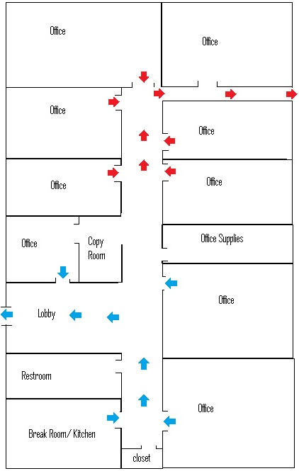

Circles of Care – Corporate (1)

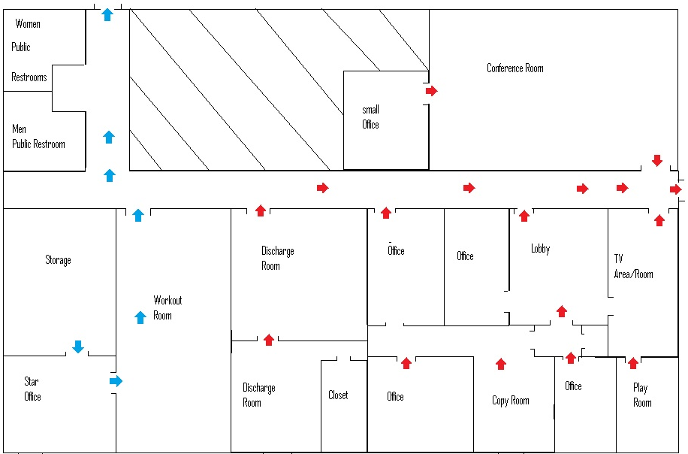

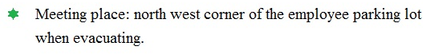

Circles of Care – Corporate (2)

5333 Everhart, Suite 150B

Corpus Christi, Texas 78411

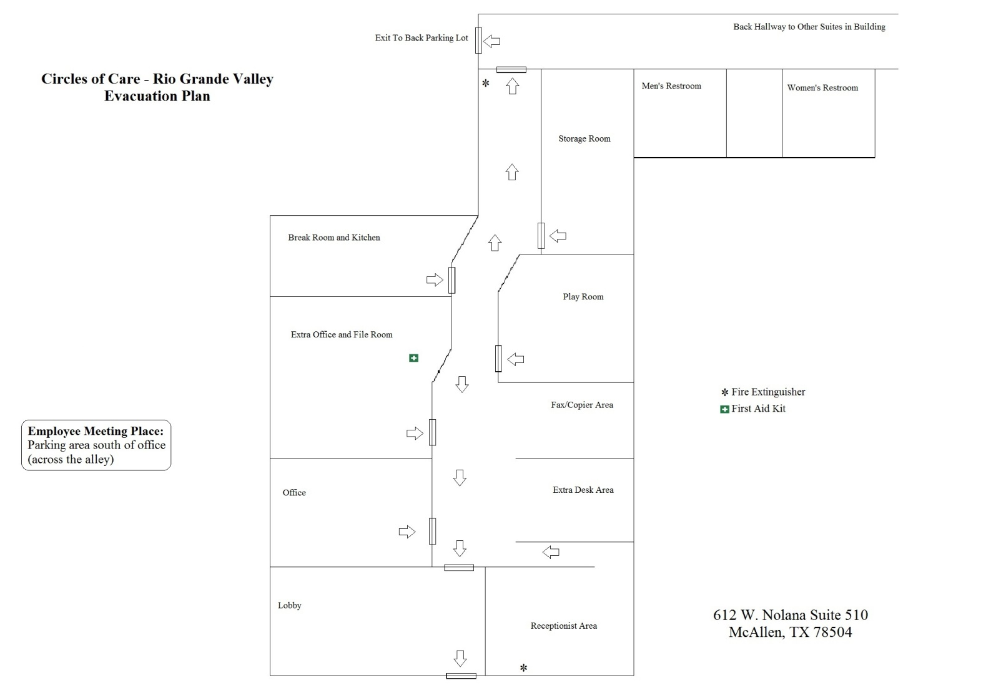

Circles of Care – RGV

612 W. Nolana Suite 510

McAllen, TX 78504

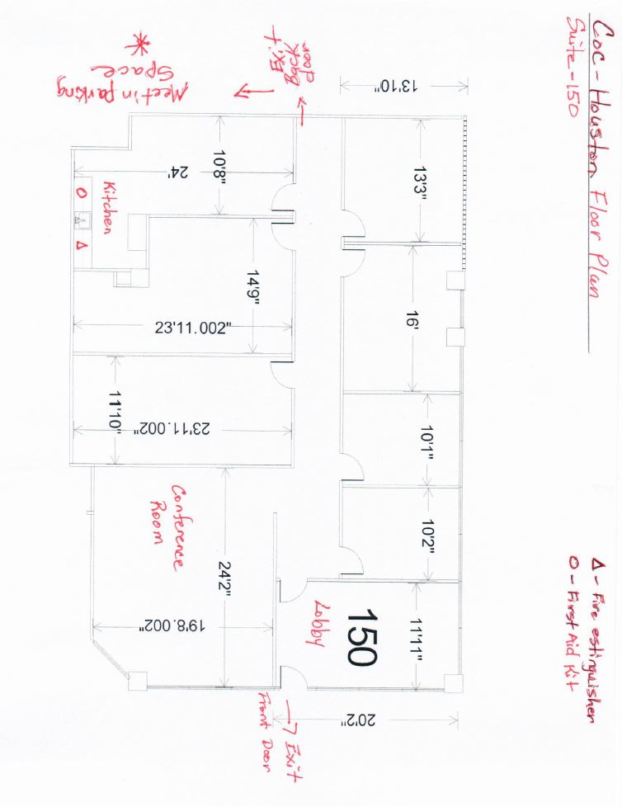

Circles of Care – Houston

340 North Sam Houston Pkwy East Suite 150

Houston, Texas 77060

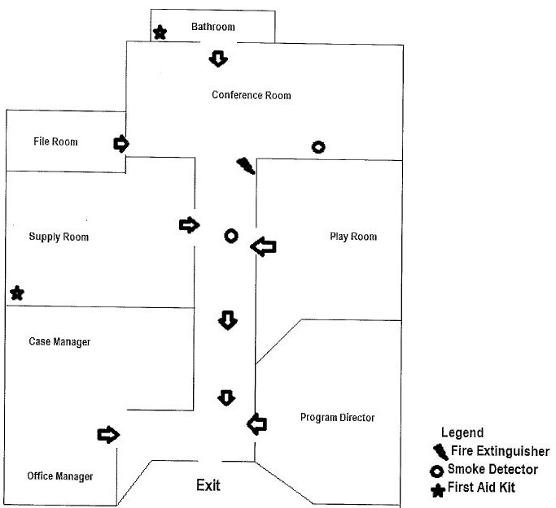

Circles of Care – Central Texas

805 N. Main Street

Salado, TX 76571

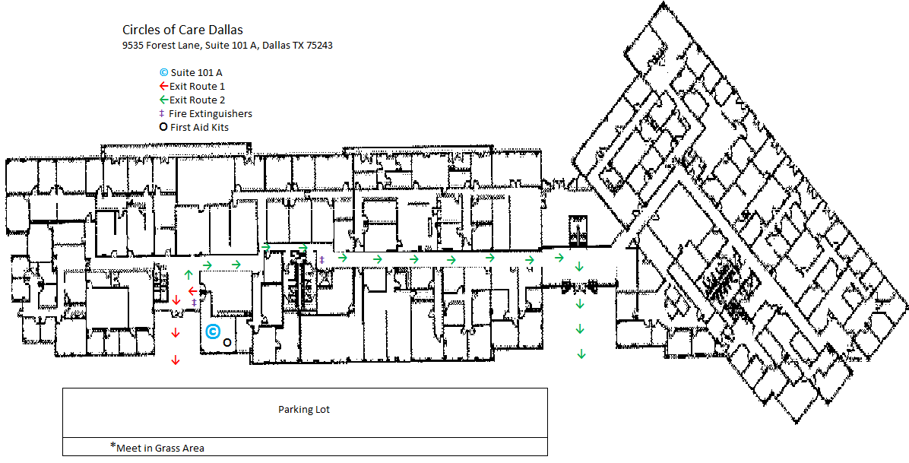

Circles of Care – Dallas

9535 Forrest Lane #101A

Dallas, TX 75243

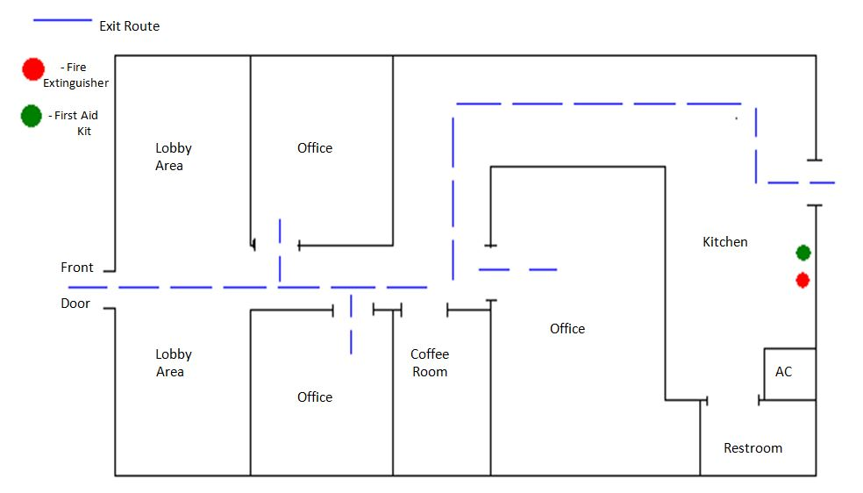

Circles of Care – Laredo

709 Alta Vista Dr. #103

Laredo, TX 78041

**Appendix B**

**Circles of Care Emergency Phone Numbers**

|  |  |  |
| --- | --- | --- |
| **Name** | **Office Number** | **Cell Number** |
| Carrie Mata –Safety Officer | 361-852-3812 | 361-876-5380 |
| Lisa Edwards –Executive Director | 361-852-3812 | 361-728-4787 |
| Mike Esquivel –State Administrator | 361-852-3812 | 361-585-5500 |
| Kirsten Wigley –Program Director | 254-947-0030 | 254-780-7680 |
| Summer Solomon –Program Director | 956-688-6948 | 361-219-4782 |
| Henry Martinez –Program Director | 361-852-3812 | 361-765-1254 |
| Cynthia Lee –Program Director | 281-260-6814 | 832-696-3850 |

**Circles of Care Emergency Codes**

|  |  |
| --- | --- |
| **Nature of Emergency** | **Code** |
| Fire | Code Red |
| Medical | Code Blue |
| Threat of Violence | Code Gray |
| Tornado | Code Orange |
| Bomb Threat | Code Yellow |

**Appendix C**

**Circles of Care Safety Check Form**

Date of check: _______________________ Done by:___________________________________

Office or facility location:_________________________________________________________

Smoke Alarm: Working/ in good order  Not working/ not in good order

If not in working order document below how remedied and date. __________________________________________________________________________________________________________________________________________________________________________________________________________________________________________

Fire Extinguisher: Passed  not passed

If not passed, document when serviced. ____________________________________________________________________________________________________________________________________________________________

First Aid Kit: present and supplies adequate  Missing or supplies low

If not adequate, document how remedied and date __________________________________________________________________________________________________________________________________________________________________________________________________________________________________________

Office/facility:  No visible or apparent hazards Visible or apparent hazards

*Refer to attached COC Work-Place Health and Safety Checklist*

If any visible or apparent hazards document what they are, how they were remedies and date. ________________________________________________________________________________________________________________________________________________________________________________________________________________________________________________________________________________________________________________________

**Appendix D**

**Circles of Care Bomb Threat Call Checklist**

Name used if applicable: _________________________________________

Exact wording of threat Caller: _____________________________________

____________________________________________________________

____________________________________________________________

When is the device going to explode? ________________________________

Where is the device (bomb) now? Building ________ Room _______________

What does it look like? ___________________________________________

What will cause it to explode? _____________________________________

Why? _______________________________________________________

When did you plant the bomb? ____________________________________

**BACKGROUND OF THE BOMB THREAT CALLER:**

Bomb Threat Caller ID if available: __________________________________

Voice: Male ________ Female _________ Accent ______________________

Nationality (if possible): ________________ Intoxicated: ________________

Speech Obstruction: ___________________ Age (approximately): _________

Background Noise: ______________________________________________

Familiar with the building: _________________________________________

If Mentioned Personnel Name: ______________________________________

Other: _______________________________________________________

*****************************************************************

Employee receiving the call: ________________________ Date: ____________

Program Area: __________________________________

Program Director: _______________________________ Date: ____________

Safety Officer: __________________________________ Date: ____________

**Appendix E**

**Circles of Care Safety Drill Form**

Date: ___________________

Type of Incident Drill: 🞏 Fire 🞏 Bomb Threat 🞏 Workplace Violence 🞏 Tornado

🞏 Other:________________________

Observations/Notes: ____________________________________________________________

____________________________________________________________

____________________________________________________________

____________________________________________________________

Staffing/Discussion/Feedback to staff: ____________________________________________________________

____________________________________________________________

____________________________________________________________

____________________________________________________________

Staff Signature: __________________________

Staff Signature: __________________________

Staff Signature: __________________________

Staff Signature: __________________________

Staff Signature: __________________________

Staff Signature: __________________________

Staff Signature: __________________________

Staff Signature: __________________________

Staff Signature: __________________________

Staff Signature: __________________________

Safety Officer Signature: __________________________ Date: ____________

**Appendix F**

**Circles of Care Health and Safety Checklist**

Program Office:_________________________________ Date: _____________

|  |  |
| --- | --- |
| Yes No NA |  |
| ❑   | 1. There are at least two unblocked exits to the outside from the building (can include windows) |
| ❑   | 1. Electrical wiring system appears in good repair |
| ❑   | 1. Electrical outlets in common areas have child-proof covers |
| ❑   | 1. Fuses or circuit breakers in fuse box appear in good operating condition |
| ❑   | 1. Cords for electrical appliances and lighting fixtures appear in good operating condition |
| ❑   | 1. Extension cords and surge protectors are used properly |
| ❑   | 1. There is an operable dry chemical fire extinguisher available for use in the office |
| ❑   | 1. Fire extinguisher is serviced after each use and checked for proper weight at least once a year |
| ❑   | 1. An evacuation plan is posted in common areas |
| ❑   | 1. Evacuation drills are practiced regularly |
| ❑   | 1. There is a method available to alert staff to a fire |
| ❑   | 1. The flooring in the office clean, and free of debris |
| ❑   | 1. Stairways and aisles are clean, unblocked and well-lit |
| ❑   | 1. Furniture and equipment is safe and well maintained |
| ❑   | 1. Fully-stocked First-Aid kit is located in the office |
| ❑   | 1. All materials and supplies are stored safely |
| ❑   | 1. All cleaning supplies are properly stored |
| ❑   | 1. Trash is cleared from the office; trash does not overflow any receptacles |
| ❑   | 1. Kitchen areas are kept clean and in order |
| ❑   | 1. Restrooms are kept clean, with available hand soap and towels |

Comments/Concerns: __________________________________________________

__________________________________________________________________

Inspection Completed By:______________________________ Date: _____________

Re-Inspection Due Date: ______________________________

Submitted to COC Safety Officer By: _______________________ Date: _____________

**Appendix G**

**Circles of Care Transportation Emergency Procedures**

Personal Safety Guidelines when transporting children:

* Ensure vehicle is in good repair, properly fueled, has written emergency procedures and emergency numbers, and has a fully-stocked First-Aid kit.
* All staff and clients must wear seatbelts when transporting or being transported by agency personnel.
* Drivers must not drive and talk on their cell phones or use other electronic devices while driving; pull off the road and make the call once the car is parked.
* Proper child restraints must be appropriately utilized, as per Texas laws.
* Any time a staff member feels unsafe with a client in their car, they should immediately contact their Program Director for assistance.

In case of an accident:

* Call 911 immediately; note the officer’s name and ask how to obtain a copy of the police report
* Record information from all parties involved (name, address, phone number, name of insurance and policy number, type of vehicle, license number, witness name and numbers)
* Contact Program Director to report the incident and request support if needed
* A Circles of Care Employee Incident Report must be completed to document the accident. If a child or youth is injured in the accident, ensure appropriate medical attention is provided. Complete a Circles of Care Serious Incident Report and follow appropriate reporting protocols.

In the event of a client emergency (posing a risk to self or others):

* Pull the vehicle to a safe location when it is safe to do so and assess the situation
* Make efforts to de-escalate the client
* Call 911 if necessary
* If a wound has been inflicted, assess the severity and apply emergency first aid, if necessary or possible.

Emergency phone numbers: 911

Carrie Mata, Safety Officer 361-852-3812 361-876-5380

Lisa Edwards, Executive Director 361-852-3812 361-728-4787

Mike Esquivel, State Administrator 361-852-3812 361-585-5500

Kirsten Wigley, Program Director 254-947-0030 254-780-7680

Summer Solomon, Program Director 956-688-6948 361-219-4782

Henry Martinez, Program Director 361-852-3812 361-765-1254

Cynthia Lee, Program Director 281-260-6814 832-696-3850

**Appendix H**

**Circles of Care Employee Incident Report**

**Date _____________________**

**Employee Supervisor**

Name **__________________** Name **___________________**

Title/position**__________________** Title/position **__________________**

**Incident**

Date _________________________________________________________

Time _________________________________________________________

Location ______________________________________________________

**Description of incident**

__________________________________________________________________________________________________________________________________________________________________________________________________________________________________________________________________________________________________________________________________________

**Employee explanation**

__________________________________________________________________________________________________________________________________________________________________________________________________________________________________________________________________________________________________________________________________________

**Witnesses**

______________________________________________________________________________________________________________________________________________________________________________________________________

**Action to be taken**

________________________________________________________________________________________________________________________________________________________________________________________________________________________________________________________________________

______________________________ ______________________________

Employee Date Supervisor Date

______________________________

Safety Officer Date